Software Requirements Specification
GIU Facility Management Mobile Application
Version 1.0
German International University (GIU)

1. Introduction
This Software Requirements Specification (SRS) document describes the functional and non-functional requirements for the GIU Facility Management Mobile Application. The application enables GIU community members to report campus issues, allows the Facility Management team to oversee and assign maintenance tasks, and provides workers with clear task assignments.

2. User Stories

2.1 Community Member (User)
As a member of the GIU community, I want to report issues so that the campus remains a clean and safe environment.

Submit Issue
I can take a photo of an issue (e.g., broken door), write a brief description, and specify its location so the team knows exactly what needs fixing.

Track Status
I can view the status of my submitted issues (e.g., Pending, In Progress, Resolved) to know when they are being addressed.

Outdoor/Indoor Reporting
I can specify whether the problem is indoors or outdoors to ensure the maintenance team can find it easily.

2.2 Facility Management Team
As a member of the management team, I want to oversee all reported issues so that I can manage campus maintenance efficiently.

View All Issues
I can see a list of all submitted problems and their current statuses to keep track of the campus condition.

Assign Personnel
I can assign specific workers to a reported issue so that the right person is notified to fix it.

Update Progress
I can manually update the status of an issue as it moves through the maintenance workflow.

2.3 Worker
As a maintenance worker, I want to receive clear task assignments so that I can resolve infrastructure problems quickly.

Receive Notifications
I want to be alerted immediately when a new task is assigned to me.

View Tasks
I can view a list of all tasks assigned to me so I can prioritize my workday.

Provide Updates
I can update the task status after I have handled the issue to notify management and the community.

2.4 Admin
As a system administrator, I want to manage user roles and permissions to ensure a structured workflow.

Role Management
I can manage different user accounts and assign them roles (Community Member, Management, Worker) to maintain system security.

4. UML Use Case Diagram
The following UML Use Case Diagram illustrates the interactions between the system actors (Community Member, FM Team, Worker, Admin, and Notification Service) and the system use cases.
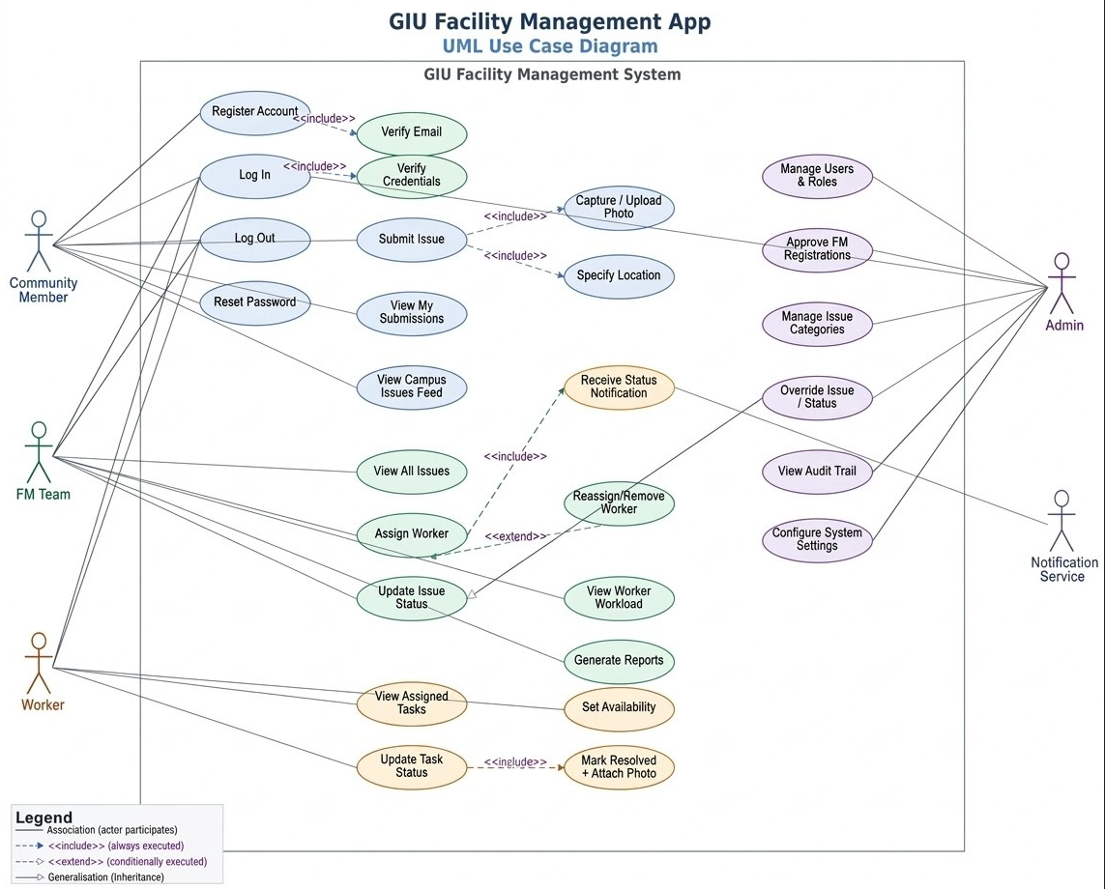

5. Functional Requirements
Functional requirements define the specific behaviours, features, and capabilities the system must provide. They are organised by functional area and cross-referenced to the user roles they serve.

5.1 Authentication & User Management
Requirement | Priority | Role(s)
The system shall allow community members to self-register using a valid GIU email address. | Must Have | Community Member
The system shall send a verification email; accounts remain inactive until verified. | Must Have | Community Member
FM Team members shall register via the app and await admin approval before gaining access. | Must Have | FM Team
Admin shall create Worker accounts; workers receive credentials by email and must change password on first login. | Must Have | Admin / Worker
The system shall authenticate all users via email and password using secure tokens (JWT). | Must Have | All Roles
The system shall provide a password-reset flow via email link for all roles. | Must Have | All Roles
The system shall enforce role-based access control (RBAC). | Must Have | All Roles
Users shall be able to log out, immediately invalidating their session token. | Must Have | All Roles
The system shall support a "Remember Me" option persisting the session for 30 days. | Should Have | All Roles
Users shall be able to update their display name and profile photo. | Should Have | All Roles

5.2 Issue Submission (Community Member)
Requirement | Priority | Role(s)
Community members shall submit a new issue by providing a title, category, description (up to 500 characters), and at least one photo. | Must Have | Community Member
The system shall allow users to capture a photo directly with the device camera or select one from the gallery. | Must Have | Community Member
Users shall specify whether the issue is indoors or outdoors with appropriate location details. | Must Have | Community Member
Upon successful submission, the system shall display a confirmation and assign a unique tracking ID. | Must Have | Community Member
Community members shall view all their submitted issues from a "My Submissions" screen. | Must Have | Community Member
Community members shall view a read-only feed of all campus issues, filterable by status and location. | Should Have | Community Member
Community members shall receive in-app and push notifications whenever a submitted issue status changes. | Must Have | Community Member

5.3 Issue Management (FM Team)
Requirement | Priority | Role(s)
FM team members shall have access to a dashboard displaying total issue counts grouped by status. | Must Have | FM Team
FM team members shall view full details of any submitted issue including photos, description, location, and status history. | Must Have | FM Team
FM team members shall search and filter issues by status, category, building/area, date range, and assigned worker. | Must Have | FM Team
FM team members shall assign an available worker to an issue; issue status shall automatically change to "Assigned". | Must Have | FM Team
FM team members shall reassign or unassign a worker; the previous worker shall be notified of the change. | Must Have | FM Team
FM team members shall manually update the status of any issue with a mandatory comment. | Must Have | FM Team
FM team members shall view a worker workload screen showing each worker's availability and active issues. | Should Have | FM Team
FM team members shall view a summary report of issue metrics including average resolution time. | Should Have | FM Team

5.4 Task Management (Worker)
Requirement | Priority | Role(s)
Workers shall receive a push notification and in-app alert immediately upon being assigned a new issue. | Must Have | Worker
Workers shall view a list of all issues currently assigned to them, sorted by assignment date. | Must Have | Worker
Workers shall open an issue to view full details: photo, description, exact location, category, and FM notes. | Must Have | Worker
Workers shall update the status of an assigned issue to "In Progress" or "Resolved" with a mandatory note. | Must Have | Worker
Workers shall attach one or more photos as evidence when marking an issue as resolved. | Should Have | Worker
Workers shall set their availability status (Available, Busy, Off-duty), visible to the FM team. | Should Have | Worker
Workers shall view a history of all previously resolved tasks. | Should Have | Worker

5.5 Administration (Admin)
Requirement | Priority | Role(s)
Admin shall view, create, edit, deactivate, and reactivate user accounts for any role. | Must Have | Admin
Admin shall assign or change the role of any user; the change shall take effect on the user's next login. | Must Have | Admin
Admin shall review, approve, or reject FM Team registration requests, with the applicant notified by email. | Must Have | Admin
Admin shall create, rename, and archive issue categories; archived categories shall not appear in the submission form. | Must Have | Admin
Admin shall have read access to all issues and be able to override any status or assignment in an emergency. | Must Have | Admin
Admin shall have access to a read-only system audit trail recording all sensitive actions. | Must Have | Admin
Admin shall configure global notification triggers and customise notification message templates. | Should Have | Admin
Admin shall view system-wide reports exportable as PDF or CSV covering issue trends and worker performance. | Should Have | Admin
Admin shall configure system parameters such as permitted email domains and session timeout duration. | Nice to Have | Admin

6. Non-Functional Requirements
Non-functional requirements define the quality attributes, constraints, and standards the system must meet.

6.1 Performance
Requirement | Priority | Category
The app shall load the home/dashboard screen within 2 seconds on a standard 4G mobile connection under normal load. | Must Have | Performance
Issue submission (including photo upload) shall complete within 5 seconds on a 4G connection for images up to 5 MB. | Must Have | Performance
Push notifications shall be delivered within 3 seconds of the triggering event under normal network conditions. | Must Have | Performance
RESTful API endpoints shall respond with a 95th-percentile latency of ≤500 ms under 200 simultaneous users. | Must Have | Performance
The backend shall support horizontal scaling to handle peak usage periods without degradation. | Should Have | Performance

6.2 Security
Requirement | Priority | Category
All data transmitted between the mobile app and the backend shall be encrypted using TLS 1.2 or higher. | Must Have | Security
User passwords shall be stored using bcrypt with a minimum cost factor of 12. | Must Have | Security
Authentication tokens (JWTs) shall expire after 24 hours of inactivity; refresh tokens after 30 days. | Must Have | Security
The system shall lock an account for 15 minutes after 5 consecutive failed login attempts. | Must Have | Security
All API endpoints shall be protected by RBAC; unauthenticated requests return HTTP 401 or 403. | Must Have | Security
User-uploaded images shall be scanned for malicious content before being stored. | Should Have | Security
Sensitive fields shall never be logged in application logs or error reports. | Must Have | Security
The application shall be protected against the OWASP Mobile Top 10 vulnerabilities. | Should Have | Security

6.3 Usability
Requirement | Priority | Category
A new community member shall be able to register, log in, and submit their first issue within 5 minutes. | Must Have | Usability
The app shall provide clear, human-readable error messages for all failure states. | Must Have | Usability
All interactive elements shall have a minimum touch target size of 44×44 dp, conforming to WCAG 2.1 AA. | Must Have | Usability
The app shall support both light and dark mode, respecting the device's system preference by default. | Should Have | Usability
All screens shall be navigable using assistive technologies (e.g. screen readers) on iOS and Android. | Should Have | Usability
The app's primary language shall be English; the architecture shall allow future localisation. | Nice to Have | Usability

6.4 Reliability & Availability
Requirement | Priority | Category
The backend system shall achieve a minimum uptime of 99.5% measured monthly, excluding scheduled maintenance. | Must Have | Reliability
Scheduled maintenance windows shall not exceed 2 hours per week and shall be performed outside peak hours (08:00–20:00 EET). | Should Have | Reliability
In the event of a backend failure, the mobile app shall display an offline message and allow issue drafting. | Should Have | Reliability
The system shall perform automated database backups every 24 hours; retained for a minimum of 30 days. | Must Have | Reliability
Critical system failures shall trigger automated alerts to the admin team within 1 minute of detection. | Must Have | Reliability

6.5 Scalability & Maintainability
Requirement | Priority | Category
The system architecture shall follow a RESTful API design pattern, decoupling the frontend and backend. | Must Have | Scalability
The backend codebase shall adhere to a modular, layered architecture (routes, controllers, services, repositories). | Must Have | Maintainability
All API endpoints shall be documented using OpenAPI (Swagger) specification, kept up to date with each release. | Should Have | Maintainability
The codebase shall maintain a unit test coverage of at least 70% for business-logic modules. | Should Have | Maintainability
Database schema migrations shall be managed through a versioned migration tool. | Should Have | Maintainability
The system shall support at least 1,000 registered users and 500 stored issues without architectural changes. | Must Have | Scalability

6.6 Compatibility & Portability
Requirement | Priority | Category
The React Native (Expo) application shall run on iOS 15+ and Android 10+ without functional differences. | Must Have | Compatibility
The app shall be compatible with screen sizes ranging from 4.7" to 6.9" using responsive Flexbox layout. | Must Have | Compatibility
The backend shall be containerised using Docker for consistent deployment across environments. | Should Have | Portability
The system shall function correctly on devices with limited connectivity (2G/3G) via request queuing and image compression. | Should Have | Compatibility

6.7 Data & Privacy
Requirement | Priority | Category
The system shall collect only the minimum personal data necessary; no third-party advertising or analytics SDKs shall be included. | Must Have | Privacy
User personal data shall be stored within the EU or in a GDPR-compliant data centre. | Must Have | Privacy
Users shall be able to request deletion of their account and associated personal data within 30 days. | Should Have | Privacy
Issue photos shall only be visible to authorised roles (FM team, assigned worker, admin); not publicly accessible. | Must Have | Privacy

7. Entity Relationship Diagram (ERD)
The following Entity Relationship Diagram illustrates the database schema for the GIU Facility Management Application, showing all entities, their attributes, and the relationships between them.
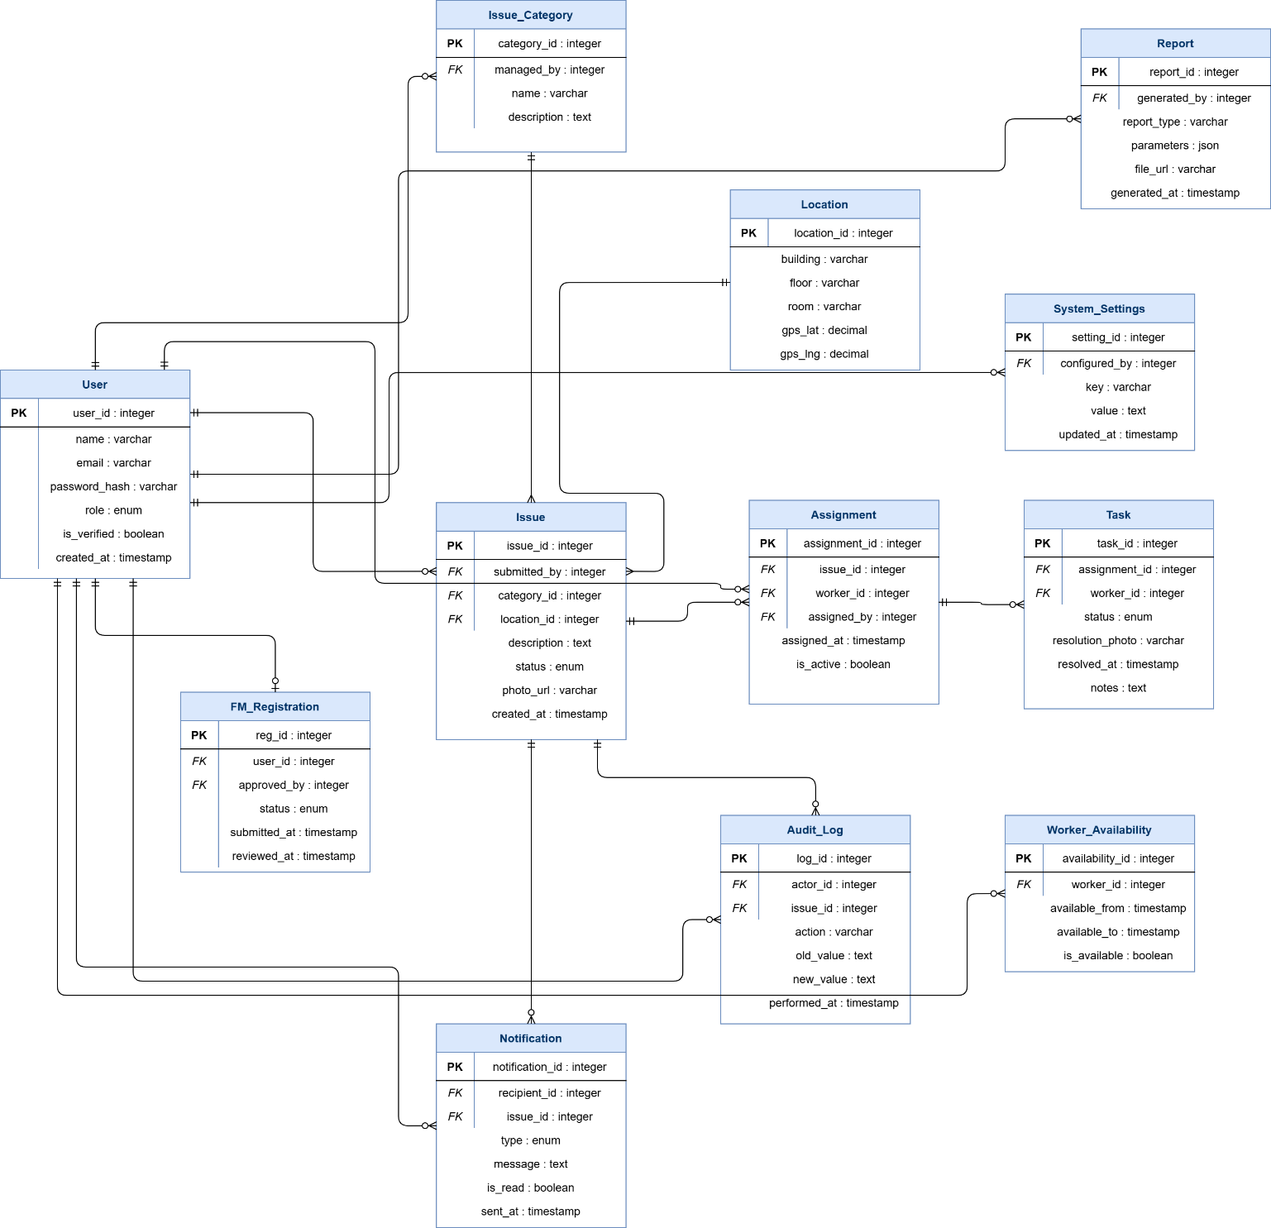

CampusCare
Database Schema Reference
PostgreSQL • Supabase • 8 Tables • Relational with FK Constraints

Overview

The CampusCare backend utilises a relational PostgreSQL/Supabase database. All primary keys are UUIDs generated via uuid_generate_v4(). Foreign key relationships enforce referential integrity. Cascading deletes are applied where child records have no standalone value.
Constraint Badge Key
PRIMARY KEY |  | NOT NULL |  | UNIQUE |  | REFERENCES |  | CHECK |  | CASCADE |  | Default

1 | users  All registered individuals — members, workers, managers, admins

Stores every user interacting with the platform. Role-based access control is enforced via the role column.
Column | Type | Constraints | Description
id | UUID | PRIMARY KEY Default: uuid_generate_v4() | Unique identifier for the user.
name | VARCHAR(100) | NOT NULL | User's full name.
email | VARCHAR(255) | UNIQUE NOT NULL | Email address used for login.
password_hash | VARCHAR(255) | NOT NULL | Bcrypt-hashed password.
role | VARCHAR(20) | NOT NULL CHECK | RBAC level: community_member | facility_manager | worker | admin.
status | VARCHAR(20) | Default: 'active' CHECK | Account standing: active | inactive | pending_approval.
employee_id | VARCHAR(50) | Optional | Internal staff ID for workers or managers.
availability | VARCHAR(20) | Default: 'available' CHECK | Worker availability: available | busy | off_duty.
profile_photo_url | TEXT | Optional | URL to the uploaded profile picture in storage.
push_token | TEXT | Optional | Device token for push notifications.
created_at | TIMESTAMPTZ | Default: NOW() | Timestamp of account creation.
updated_at | TIMESTAMPTZ | Default: NOW() | Timestamp of last account update.

2 | categories  Issue type classifications available in the system

Defines the maintenance issue types. Archived categories remain in historical data but are hidden from new submissions.
Column | Type | Constraints | Description
id | UUID | PRIMARY KEY Default: uuid_generate_v4() | Unique identifier.
name | VARCHAR(100) | UNIQUE NOT NULL | Category name, e.g. Electrical, Plumbing.
icon | VARCHAR(50) | Default: 'alert-circle' | UI icon reference name (Lucide / Expo icons).
is_archived | BOOLEAN | Default: FALSE | Flags deprecated categories hidden from new submissions.
created_at | TIMESTAMPTZ | Default: NOW() | Timestamp of creation.

3 | issues  Core entity — submission, assignment, and lifecycle of maintenance requests

The heart of CampusCare. Tracks every maintenance request from initial submission through assignment, progress, resolution, and closure.
Column | Type | Constraints | Description
id | UUID | PRIMARY KEY Default: uuid_generate_v4() | Internal unique identifier.
tracking_id | VARCHAR(20) | UNIQUE NOT NULL | User-facing readable ID, e.g. ISS-12345.
title | VARCHAR(200) | NOT NULL | Brief headline of the issue.
description | TEXT | CHECK (length ≤ 500) | Detailed explanation of the problem.
category_id | UUID | REFERENCES categories(id) | Foreign key linking to the issue category.
status | VARCHAR(20) | Default: 'pending' CHECK | Lifecycle stage: pending | assigned | in_progress | resolved | closed.
location_type | VARCHAR(10) | NOT NULL CHECK | Broad location context: indoor | outdoor.
building | VARCHAR(100) | Optional | Name or identifier of the building.
room_floor | VARCHAR(100) | Optional | Specific room number or floor.
location_description | TEXT | Optional | Additional details for locating the issue.
latitude | DOUBLE PRECISION | Optional | GPS coordinate for map plotting.
longitude | DOUBLE PRECISION | Optional | GPS coordinate for map plotting.
photo_url | TEXT | Optional | Primary evidence photo URL.
submitted_by | UUID | NOT NULL REFERENCES users(id) | Foreign key to the reporting user.
assigned_to | UUID | REFERENCES users(id) | Foreign key to the assigned worker.
resolved_at | TIMESTAMPTZ | Optional | When a worker marked the issue resolved.
closed_at | TIMESTAMPTZ | Optional | When a manager officially closed the issue.
created_at | TIMESTAMPTZ | Default: NOW() | Timestamp of issue submission.
updated_at | TIMESTAMPTZ | Default: NOW() | Timestamp of last modification.

4 | issue_photos  1-to-many photo attachments linked to issues over time

Allows multiple photos to be attached to a single issue. Photos are typed as either submission evidence or resolution proof.
Column | Type | Constraints | Description
id | UUID | PRIMARY KEY Default: uuid_generate_v4() | Unique identifier.
issue_id | UUID | NOT NULL REFERENCES issues(id) CASCADE | Foreign key to the parent issue.
photo_url | TEXT | NOT NULL | Cloud storage URL of the uploaded image.
type | VARCHAR(20) | Default: 'submission' CHECK | Photo context: submission | resolution.
uploaded_by | UUID | NOT NULL REFERENCES users(id) | The user who uploaded the photo.
created_at | TIMESTAMPTZ | Default: NOW() | Upload timestamp.

5 | status_history  Audit trail of every issue state transition

Immutable log capturing every status change on an issue. Essential for accountability, analytics, and compliance.
Column | Type | Constraints | Description
id | UUID | PRIMARY KEY Default: uuid_generate_v4() | Unique identifier.
issue_id | UUID | NOT NULL REFERENCES issues(id) CASCADE | Foreign key to the parent issue.
old_status | VARCHAR(20) | Optional | Previous status before the change.
new_status | VARCHAR(20) | NOT NULL | Updated status after the change.
changed_by | UUID | NOT NULL REFERENCES users(id) | The user who triggered the status change.
comment | TEXT | Optional | System or user note justifying the change.
created_at | TIMESTAMPTZ | Default: NOW() | Timestamp of the state transition.

6 | comments  User-generated communication threads linked to issues

Enables workers, managers, and admins to discuss and update issues via threaded comments.
Column | Type | Constraints | Description
id | UUID | PRIMARY KEY Default: uuid_generate_v4() | Unique identifier.
issue_id | UUID | NOT NULL REFERENCES issues(id) CASCADE | Foreign key to the parent issue.
user_id | UUID | NOT NULL REFERENCES users(id) | Author of the comment.
text | TEXT | NOT NULL | Content of the message.
created_at | TIMESTAMPTZ | Default: NOW() | Timestamp of message posting.

7 | notifications  System-generated alerts pushed to users

Stores notifications triggered by issue updates, assignments, comments, or system events. Tracks read/unread state per user.
Column | Type | Constraints | Description
id | UUID | PRIMARY KEY Default: uuid_generate_v4() | Unique identifier.
user_id | UUID | NOT NULL REFERENCES users(id) CASCADE | Recipient of the notification.
title | VARCHAR(200) | NOT NULL | Subject line / headline of the alert.
body | TEXT | Optional | Detailed message content.
type | VARCHAR(30) | Default: 'status_change' CHECK | Trigger type: status_change | assignment | comment | system.
is_read | BOOLEAN | Default: FALSE | Tracks whether the user has viewed the alert.
issue_id | UUID | REFERENCES issues(id) | Optional link to a related issue (SET NULL on delete).
created_at | TIMESTAMPTZ | Default: NOW() | Timestamp of notification generation.

8 | audit_log  Admin-level tracking of high-impact system actions

Administrative audit trail for compliance and debugging. Records who did what, to which entity, and when.
Column | Type | Constraints | Description
id | UUID | PRIMARY KEY Default: uuid_generate_v4() | Unique identifier.
actor_id | UUID | REFERENCES users(id) | The administrator or user performing the action.
action | VARCHAR(100) | NOT NULL | Event description, e.g. USER_ROLE_UPDATED.
target_type | VARCHAR(50) | Optional | Entity type affected, e.g. user or system.
target_id | UUID | Optional | ID of the specific entity affected.
details | JSONB | Optional | Deep metadata or before/after deltas of the action.
ip_address | VARCHAR(45) | Optional | Captured IP address of the actor.
created_at | TIMESTAMPTZ | Default: NOW() | Timestamp of the logged event.

⚡ Key Indexes — Performance Optimisations

The following indexes are maintained to ensure rapid query execution on common dashboard and filtering views.
Table | Indexed Columns
issues | issues.status • issues.submitted_by • issues.assigned_to • issues.category_id • issues.created_at
notifications | notifications (Compound: user_id + is_read)
status_history / comments | status_history.issue_id • comments.issue_id
users | users.role • users.email

